Yash Saboo, 1st year CS grad student

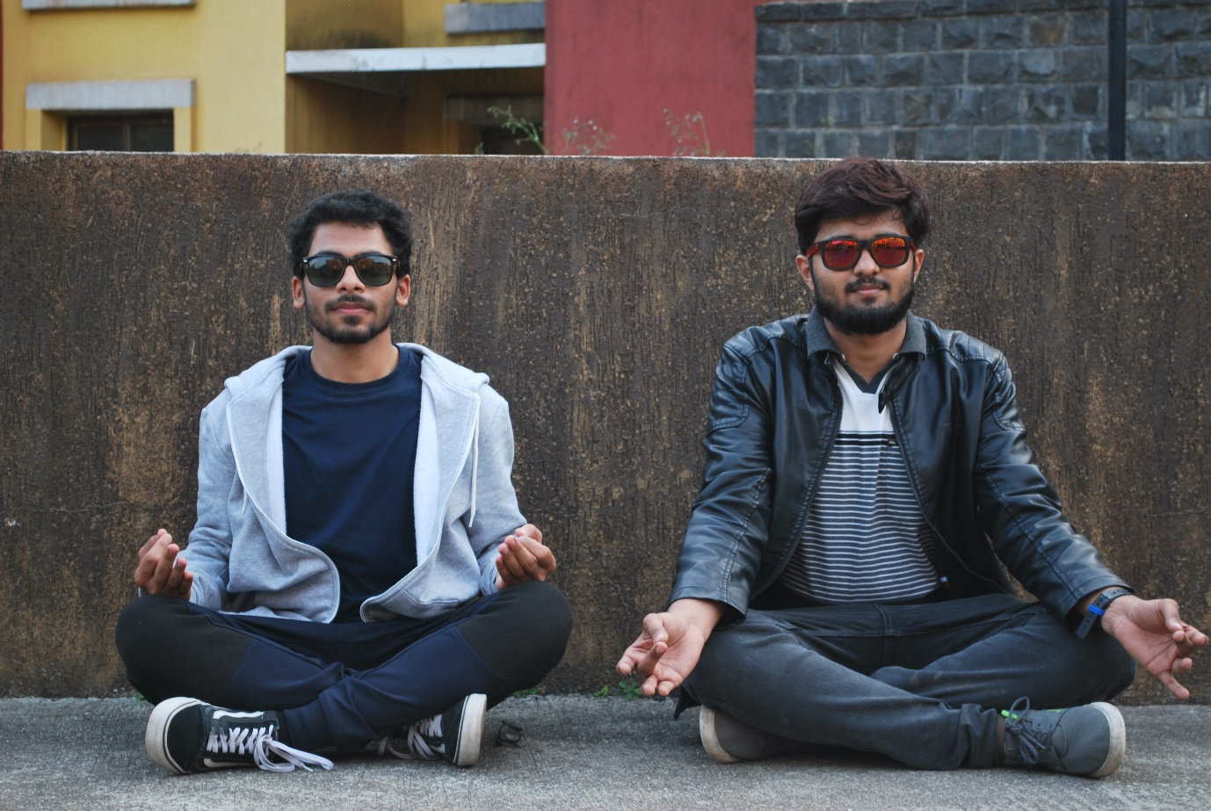

Professional aspirations:

1. Code for 7 years at XYZ company

2. Code for 7 years at your own company (Startup?!)

3. Sell the company and go back to previous step

Hobbies and Likes/Dislikes:

1. First Love: Music (Bad singer, but that didn’t stop Meghan Trainor)

2. Sports: Soccer, Cricket, Chess, Surfing(did it just once, but in awe)

3. TV Show/Movies: Money Heist and Peaky Blinders (if you haven’t watched them, then what are you doing?)

Fav Restuarant here:

I don’t have a favorite restaurant yet (need suggestions!). I cook most of the time, so if you like Indian food, hit me up!